

**AGE GROUP PROGRAM**

**JUNIOR PROGRAM**

* The Carina Leagues Triathlon Club has access to or own many excellent facilities and equipment.
* These include a heated 50m pool, a recovery centre with eight person ice bath, running tracks, over 50 windtrainers and rollers, swim paddles and pool buoys.
* For more information visit our website http://www.carinaleaguestriathlonclub.com/

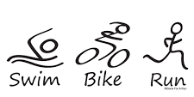

**Clem Jones Centre Carina, QLD 4152  
 Coach Rob Foxley-Conelly 0419 758 431**

**Clem Jones Centre Carina, QLD 4152  
 Coach Anthony Fletcher**

**0411 326 005**

**Training Monday to Thursday   
4.15pm – 6.00pm:   
Saturday:   
6.00am – 9.00am**

**Training Monday to Friday   
5.30am – 7.00am:   
Saturday:   
5.30am – 9.00am**

**AGE GROUP**

**JUNIORS**

Come and Join the Fun at the  
 Carina Leagues Triathlon Club   
with Squads to Suit All Ages and Abilities