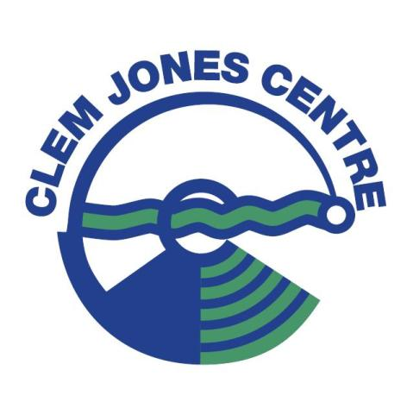
Lockdown Lifted
The Clem Jones Centre will reopen at 5AM Monday 9th of August 2021

Please wear your masks and check in with the QLD check in app. Please sanitise on entry and before you leave the facilities.

New restrictions of 1 person per 4m2 at all time.

Hydrotherapy will be available from 6AM.
Swim school lessons recommencing at 7:30AM.

Thank you
Centre Management

